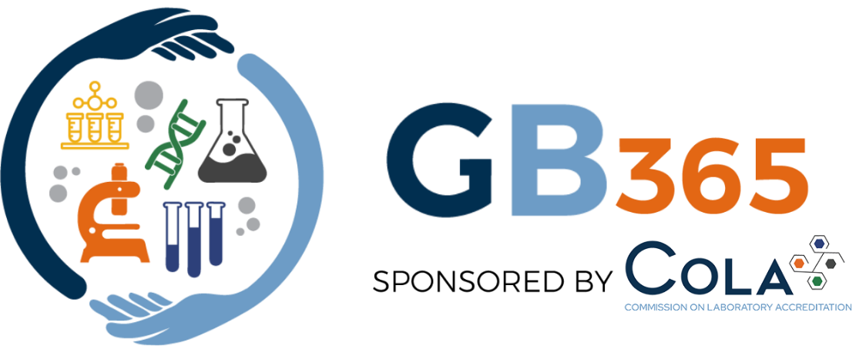

The GiveBack365 Scholarship
COLA is pleased to offer $1,500 scholarships to aid students currently pursuing a degree in the field of Medical Laboratory Science within an accredited program. This scholarship was formed in 2012 to foster awareness of careers in the medical laboratory and to support the individuals who will become the future of the industry.
COLA, Inc. is a physician-directed organization whose purpose is to promote health and safety through accreditation and educational programs. In 1993, COLA was granted deemed status by CMS to provide laboratory accreditation. As a leading laboratory accreditor in the United States, COLA operates its laboratory accreditation program in accordance with a quality management system certified to ISO 9001. This means we offer our customers a unique, standardized program and staff dedicated to satisfaction and laboratory quality. Our Surveyors and Technical Advisors are guided by a coaching approach and uncomplicated quality engineered processes. Laboratories of all types and sizes are evaluated and mentored to produce the highest quality laboratory services and meet CLIA regulations.
At the heart of COLA’s mission, there is one objective: to enhance patient safety. COLA supports that objective through exciting opportunities to celebrate its successes, engage in professional development and community reinforcing activities, as well as give back efforts. COLA continues to increase awareness about the medical laboratory sciences professions through the GiveBack365 Scholarship Program.
Applicants must meet the following criteria:
- Be actively enrolled and in good standing within a Medical Laboratory Science Cytology, or Histotechnology program at an accredited institution in the US or US territories.
- Have successfully completed one semester in their program
- Be seeking an associate, baccalaureate or master’s degree Please include in your application packet:
- Completed signed application form
- An unofficial school transcript indicating your enrollment in a laboratory science program.
- A letter of recommendation from someone that knows you in an academic, work or professional capacity.
- An essay of approximately 500 words on the following topic:

Write a persuasive essay explaining which laboratory discipline — Anatomic Pathology, Chemistry, Hematology, Immunology, Immunohematology or Microbiology— plays the most critical role in healthcare? Provide three compelling examples to support your argument.

Please submit the completed application and all supporting materials via email to scholarships@cola.org no later than November 1, 2025.

The scholarship selection committee will verify all eligibility requirements are met and group applications by degree. A team of volunteer COLA staff members will evaluate the letter of recommendation, short answer questions and essay. Scores are compiled for each candidate. The applicants receiving the highest scores in each degree (associate, bachelor and advanced degrees) are awarded scholarships. Winners will be notified by email on or before Jan 2, 2026.

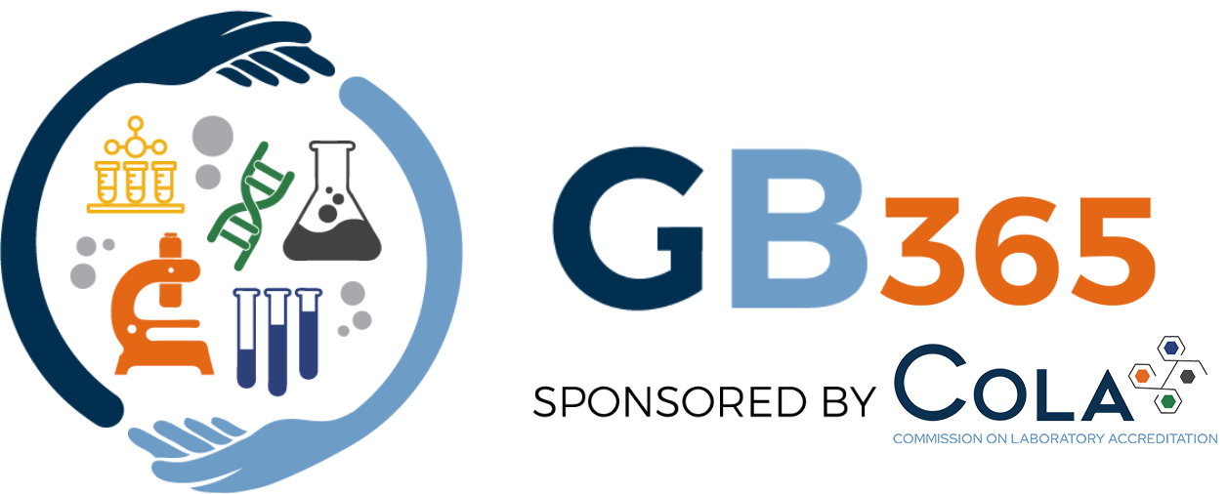
Applicant Information

Name
Email
Mailing address
Phone

Program of Study:

College or University
Title of degree program
Type of degree
Program Director name
Program Director email

Attach copy of most recent unofficial transcript

Letter of Recommendation:

Select an individual that knows you well from an academic, work or professional capacity and can communicate how you will contribute to advancing the field of Medical Laboratory Science. Provide the selected individual with this link to prepare their letter of recommendation.

Once the recommendation is written, please include the letter with the rest of this application.

COLA’s scholarship committee is a team of volunteers that are passionate about our careers in medical laboratory science. We value hard work, professionalism, lifelong learning, and the desire to give back. In the short answer questions below, please tell us a little bit about yourself, your accomplishments, your challenges and your desire to help others succeed.

Short Answer questions (maximum of 300 words each)

- Why did you select medical laboratory science as a field of study?

- What challenges have you encountered in pursuit of your education?

- What is your greatest accomplishment to date and what makes it significant to you?

- How will receiving this scholarship inspire you to give back?

Essay question: (Approximately 500 words)

Please note we are looking for your individual thoughts and opinions. Please do not submit an essay created using artificial intelligence.
Write a persuasive essay explaining which laboratory discipline — Anatomic Pathology, Chemistry, Hematology, Immunology, Immunohematology or Microbiology— plays the most critical role in healthcare. Provide three compelling examples to support your argument.

Terms and Conditions:

I hereby authorize and give permission to COLA, Inc. to edit, alter, copy, exhibit, distribute and publish in print, video, audio recorded productions, and on the GB365 Website and social media my name, picture, written work, voice, verbal statements, portraits (video or still), and likeness in whatever format and medium (collectively referred to as the “Materials”) for purposes of publicizing COLA’s programs or other lawful purpose in furtherance of COLA, Inc’s commercial interests without payment or any other consideration. I understand that the Materials will be used only for nonprofit/educational purposes and that COLA, Inc. will not release the Materials to any other nonprofit or commercial entity without seeking my permission. I further understand that any proceeds from the sale of published or printed matter containing the Materials will be used to support the mission of COLA, Inc. and will become the property of COLA, Inc. and will not be returned to me. In addition, I waive the right to inspect or approve the finished product, including written or electronic copy, wherein my likeness or written work appears. I waive any right to royalties or other compensation arising or related to the use of the Materials. I hereby hold harmless and release and forever discharge COLA, Inc. from all claims, demands, liability and causes of action which I, my heirs, representatives, executors, administrators, or any other persons acting on my behalf or on behalf of my estate have or may have by reason of this authorization. This authorization is continuous and may only be withdrawn by my specific rescission of this authorization.

Applicant Signature
Date

